ECE Class Kit Vending Machine  
Project Proposal

Nidhay Patel   
Department of Electrical and Computer Engineering  
*Tennessee Technological University*   
*Cookeville, United States of America*  
*npatel45@tntech.edu*

Austin Sigg  
Department of Electrical and Computer Engineering  
*Tennessee Technological University*   
*Cookeville, United States of America*  
*aesigg42@tntech.edu*Dillon Williams  
Department of Electrical and Computer Engineering  
*Tennessee Technological University*   
*Cookeville, United States of America*  
*dswilliams42@tntech.edu*

Ryan Reed  
Department of Electrical and Computer Engineering  
*Tennessee Technological University  
Cookeville, United States of America*  
*rcreed42@tntech.edu*Michel Turpeau  
Department of Electrical and Computer Engineering  
*Tennessee Technological University  
Cookeville, United States of America*  
*mmturpeau42@tntech.edu*

# Introduction

Every year hundreds of students require various devices for their ECE classes. These specific devices are provided by the College of Engineering and are rented out to students through the ECE office. Typically, in the first month of a semester, a considerable number of students attempt to check out these devices from the ECE office. This capstone project will focus on designing and implementing a vending machine that can distribute devices out to students while recording which students have checked out a device.

The finished product will be a vending machine with the functionality to vend the needed specific devices to students. A student can enter their information into the machine, and the machine will record who has checked out their respective device(s). The machine will have a transparent front, which will allow students to see and determine which device is the one they need. The student will then put in the correct input into the vending machine, and a platform will lift up to the desired device and bring it down to vend it to the student.

The ECE office will benefit from having this machine because it will reduce traffic in the ECE office. It will also ease the process for the students because they will not have to fill out the paperwork; The vending machine will allow the office to view the data submitted by the students. As a result of this new vending system, the office associates will not have to fill out paperwork on students as frequently, and the machine will remember the data that the students enter.

The first prototype of the vending machine will have the capability to prevent boards from getting stuck, have a touch interface for students to enter information on, have a locked door to enable associates to restock the machine, and have memory in the event of a fault or power loss: to remember its functionality. Also, the machine will be fitted with a method of communication for the associates to procure student information from it. Security will be implemented to prevent boards from being stolen and to protect the database.

The objective of this capstone project is to make the process of checking out required ECE course devices simpler by utilizing a vending machine, while also recording all information given by students through a database.

# Formulating the Problem

This section will introduce the background information needed for the project. This includes the constraints of the machine, the specifications of the machine, and the standards we will be bound to while working on the project. A survey of viable solutions to the problem will also be given, so the project can be further improved in the future.

## Background

The project relies a lot on the background information of the systems in vending machines and on how these systems operate. The project will require knowledge in the areas of controls, programming, embedded, power, databases, and various others.

Vending machines are used throughout many businesses and are a source of convenience for the customers who use them. The needed maintenance on well-made vending machines is also low: saving time and money for the business [1]. A vending machine for the distribution of class kits in the ECE office would be of great convenience to students who could now come by and pick up the device that they need with ease. It would eliminate the need to fill out the paperwork in the office required to obtain a board, and it would allow the office associates to do their own work without worrying about the students.

The desired project is difficult enough to necessitate for multiple people to assist in the creation of the machine. The machine requires its own control system and power system to operate correctly. It must also have a computing system to control the platform and motors that dispense the board for the student. The machine must also have an onboard database system that is able to keep track of students and communicate with the office associates so that they know who has retrieved a board. The machine also requires some type of security system to prevent student information from being stolen, and physical security such as a lock is required to protect the devices from being stolen. The reason we do not require a machine that is “off the shelf” is that all current vending machines drop the items above to the bottom of the apparatus; The devices in the ECE office are sensitive and prone to breaking if dropped from such a height as most vending machines do. Also, most vending machines are paid services requiring the customer to buy the product whereas ours is for renting the product without any charge. Our team of engineers is responsible for the design of electrical and computer systems, and the mechanical team is responsible for the actual physical structure of the machine--our part of the project cannot be bought and requires a distinct design.

The objective of the class kit vending machine is to have a machine that is capable of recording student and class information and using that information to know which specific device is required for each student. Then the machine can properly retrieve and distribute that device to the student and record that the student has borrowed the device from the ECE department. In order for the machine to accomplish its given task, a power system, a microcontroller, sensors, motors, a student database, controls, an interface, and a PLC will all be integrated into the vending machine.

The proposed power system for the machine would utilize a 120 W AC to DC converter (Figure 1) as its source. The converters can range in output from 12V DC to 54V DC, and they need to be high efficiency to avoid overconsumption [2]. A benefit of a high-efficiency power supply is that the machine remains cooler, increasing the lifetime of the machine [2]. Extra Fuses will be included as another layer of protection to ensure that the voltage of the system devices is not exceeded. If needed, the team may also include a backup power supply, in case the system fails.

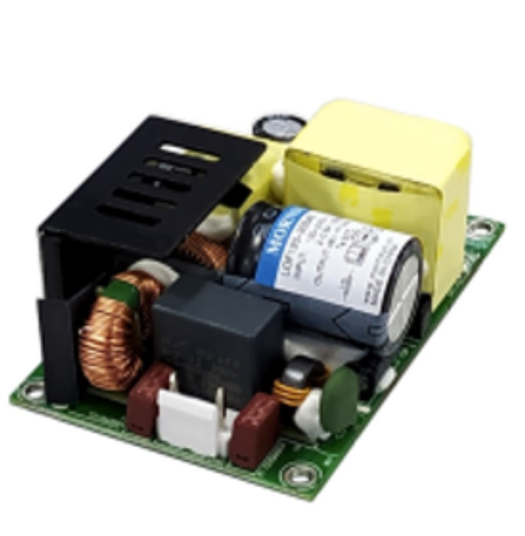

*Figure 1: 120W Power Supply*

The machine requires a microcontroller/computer to control the electronics inside and to hold a database that records every student who has obtained a board. The computer will also control the vending machine interface that the student uses to check out a device. The computer could be used to possibly control if we implement one, a card reading device as well.

For vending the devices, the team has ideas on what type of motor to use. One option is to use normal vending machine parts such as the coils with stepper motors; Another option is a belt and gate system which moves only the device that has its gate opened. Either option requires the team to implement a platform that can raise and lower--to retrieve the device for the student.

## Specifications

The class kit vending machine must follow several specifications to achieve the customers’ desired objectives. First, the team must prevent the devices from getting stuck in the machine. However, regular vending machines are prone to products becoming stuck, which results in people shaking and potentially damaging the machine [3]. The machine must be large enough to accommodate any device the ECE department places into the machine.

Secondly, the customer requires that the machine will have some form of communication so that the information can be retrieved from the machine. Most vending machines communicate through telemetry, which allows the machine to connect to the internet [4]. Some machines that are connected to the internet are vulnerable to hacking and can sometimes cause issues with other devices, which is why the team is considering alternative methods [5].

The vending machine must be able to keep track of each student’s Tech email, name, ID, and class. To know what device is checked out, the machine’s database must also know which board number is taken. An interface is required on the machine for the student to enter board numbers into the database after the device is vended.

The machine requires a fault option for when the power is lost, and the machine must remember what was entered before the power loss. Security must also be present to prevent anybody from stealing a board out of the machine after a power loss, which will probably be a type of physical lock. Lastly, the machine must be large enough to fit enough devices so as not to require the office associates to refill the machine too often.

## Constraints

The vending machine must follow certain constraints to properly be designed for the ECE office. The machine will be plugged into the wall, and must, therefore, follow the national electric code to be allowed for use. The national electric code of the United States is the NFPA 70, which is the benchmark for the safe design and installation of electric devices [6].

The machine must be smaller than a normal vending machine because it must fit inside the ECE office without obstructing the work environment. Also, for communication purposes, if Bluetooth is used, the machine can only operate on a 2.4 GHz frequency to avoid conflict with wireless networks [7].

The team must also adhere to student data privacy regulations from the school, and the team must provide safety measures for the machine to prevent any confidential information leaks such as names and IDs.

## Standards

To ensure our team can successfully and safely implement our vending machine, we must understand the standards under which the machine will have to comply. These standards come from both IEEE and the U.S. government, and we must comply with both.

One of the most important standards we must hold to is the National Fire Protection Association 70 (NFPA 70), also known as the National Electric Code (NEC). This standard covers a sizable portion of our safety regulations: installations of connections, circuit protection, wiring, and general-purpose equipment such as cords, receptacles, and switches. Also, this standard covers the installation of electrical conductors and equipment “…used by the electric utility, such as office buildings…that are not an integral part of the generation plant…” [8]. These regulations are just the surface of the NFPA 70 standard. Our team must familiarize ourselves with this standard, more than anything else, so as to successfully implement our vending machine in a way that does not endanger people or the surrounding environment.

Another standard similar to the NFPA 70 that we must comply with is the IEEE C2-2023 code; This code is similar to the NFPA 70, in that it involves standards related to those covered in the NFPA 70. IEEE C2-2023 is the National Electrical Safety Code(R) (NESC(R)) that “…includes the work rules for the operation of electric supply and communication lines and equipment,” [9]. This standard covers more specific elements like working with the electrical communication and wiring rather than being an overall standard for all things electrical, like the NFPA 70.

Finally, one more standard we must comply with is IEEE Policy 7.8. This is the Code of Ethics that every electrical and computer engineer must comply with in to conduct any form of professional engineering work. This code of conduct requires that all engineers “uphold to the highest standard of integrity, responsible behavior, and ethical conduct in professional activities,” and “to treat all persons fairly and with respect, to avoid harassment or discrimination, and to avoid injuring others,” [10]. While IEEE Policy 7.8 does not cover anything involving electrical work specifically, it is a crucial standard we much adhere to. Without this policy, there is no guarantee that a project will be ethical or safe for the public. This policy also helps encourage our team members to keep each other accountable for upholding good ethical behavior as we work on our capstone project.

## Survey of Possible Solutions

Because the use of vending machines is such a widespread practice in the modern-day marketplace economy, there are several potential solutions out in the market. One option is the smart vending machine; The smart vending machine would be a reasonable solution to our problem because of its convenience. A smart vending machine implements a touchscreen with digital transactions so as to become a more service-oriented machine [11]. This would help solve the issue of convenience for the ECE office and the student. In a non-smart vending machine, buttons can get jammed and lock up.

Another potential solution to our problem is an elevator vending machine. The general snack vending machines use a coil to keep their products on the shelves, and when a product is requested, the product is dropped down into the collection bin. An elevator vending machine has a platform that raises to the level of the selected product, and the product is pushed onto the platform via a conveyor belt or a gate [12]. The product is then lowered down into the collection bin rather than being dropped. This is another potential solution to our problem because we cannot drop the devices used in the labs; these kits and devices can be very fragile, and even a small fall could severely damage them.

One final solution that could be implemented is an array of lock boxes. The mechanical engineering team that we are collaborating with suggested using a series of lockboxes that could be refilled. When a student wants to check out a specific board, the door of the box with that board would be unlocked for them to take out that device. When the box becomes empty, the staff would refill it. Our team believes that this solution could work, but it would have to be refilled more frequently than a regular vending machine. We also believe that a series of lockboxes would occupy significantly more space than a regular vending machine.

## Summarizing the Problem

The existing solutions for our problem statement do not meet the specifications that we desire--at least not each one on its own. The vending machine for the ECE office should have a customer-friendly interface, such as that of the smart vending machine. Our vending machine should also have a lift and conveyor to safely dispense the kits, similar to that of the elevator vending machine. Given our background information, specifications, and constraints, our vending machine should be able to communicate through telemetry, safely and securely dispense the kits and boards, store and protect the information entered by each student, and reliably restart when there is a power outage. No lone vending machine that is available now can fill all of these specifications, and that is why our project is important to the ECE Department.

# Looking Toward a Solution

This section of the proposal will outline how the team will start crafting a solution based on the current problem. To be able to formulate the solution, the team must determine the critical unknowns of the project. The team will attempt to measure the success of the solution and provide proof of the success through different experiments. The broader impacts, ethics, responsibilities, and the scope of the class kit vending machine are considered with the proposed solution to creating the machine.

*A. Systems*

The following diagram in section C relays the proposed layout of the systems within the machine. Some of the systems will include the power, sensors, motors, MCU, and mechanical system. The mechanical senior design team will design the mechanical system, while the rest of the vending machine’s systems are left up for us to design. The power system will focus on the voltage level of components and the system that will be plugged into the wall. The sensor system will consist of tracking the level of the platform that will vend the devices. The MCU system will consist of the computer PCB and the system to send signals to the motors of the machine.

*B. Critical Unknowns*

One of the most important unknowns that we must account for is a potential power outage. This is important to understand because if there is a power outage and the vending machine does not have memory, the previous state and the commands will be lost thereafter. This is one of the worst-case scenarios for our machine since it could result in the loss of the stored memory of who has checked out a board and what board they checked out. The safety measure that our machine will have implemented to prevent this is non-volatile memory; Having this memory will allow the vending machine to remember and reboot its previous state in the event of a power outage.

Another critical unknown for the machine is the security of the database. This is dependent on how we decide to have the vending machine communicate with the ECE office. If the communication is through Bluetooth or Wi-Fi, someone using a program such as Wireshark could access the data that is being transmitted. This is a substantial issue and risk because the students’ information needs to be held private and secure. One way we can take a countermeasure is by using Ethernet to communicate instead of Bluetooth or Wi-Fi; It is significantly harder to access data being transmitted if it is through a wired connection such as Ethernet.

A final critical unknown that could occur is a surge--not necessarily a power outage, but a current overload in the power system. This could cause a shortage in the vending machine circuit and ruin its functionality. A countermeasure to this could be a surge protection circuit added to our AC power intake. Though it may not fully prevent damage from a surge, it can help mitigate the damages.

## C. Measurements of Success

To properly observe and measure the progress of this project, there are methods of validation placed along the track. These methods will not only more clearly show the progress achieved over time, but they are also an effective way to plan out and strategize our next course of action--by working with these constraints and problem solving the unknowns to mark success.

In its ideal form, the system would be able to process the user’s inputs and dispense the requested device post-haste. To achieve this, specific requirements need to be met for the processing power of our main controller and the speed of the lift and belt motors to be effective. There is also the need to consider a safe speed for the mechanical components and the proper power that needs to be supplied. Efficiency, while a top priority, will not take president over safety.

Since this device will primarily be utilized by consumers, the system must have an intuitive system. To measure success, periodic user tests will assess the ease of use and examine any complications or bugs; both future operators and potential customers will perform these tests.

Another way to measure success will be to progress the microcomputer and its data storage and transfer capabilities. As well as its practicality for both students and operators. There will also be testing for the security of the data stored, using "unorthodox" methods to evaluate the difficulty of breaching the system.

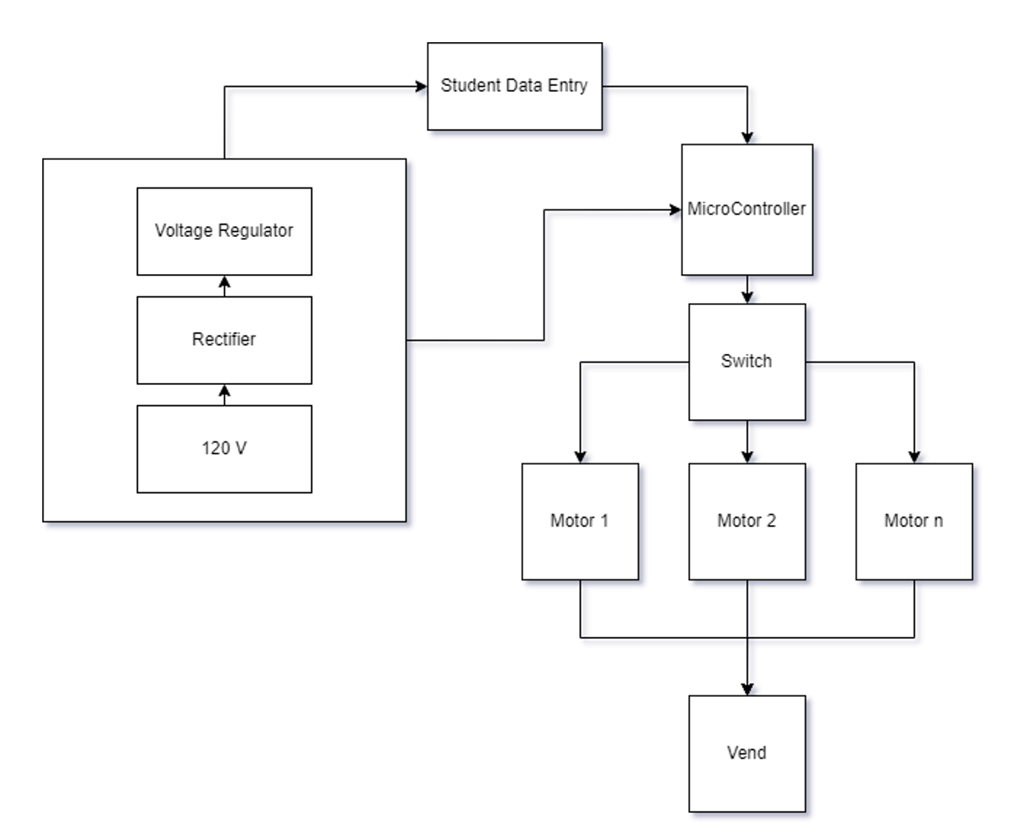

*Figure 2: Formulated Layout of Machine*

## D. Impacts, Ethics, and Responsibility

Normally with design projects, there are certain negative impacts that can arise. Our design will not displace any workers on the campus because the vending machine is meant to make the office associates’ jobs easier, not to replace their job. The machine will allow students to get a board without interrupting the associate’s work. The only requirement from the associate is to refill the machine when it is low on its stock. This means that no jobs will be affected by the introduction of the machine. The machine has the potential to take some workload off of the office workers as well.

The main possible negative impact associated with the vending machine is the risk of a fire. The machine will need to go through heavy testing to ensure that the machine cannot fail and cause a fire in the college building; The machine must have a fully redundant power system to avoid causing a fire. The plan is to have a backup power system in parallel with the primary one to have a way to shut off a system if it fails. Also, fuses will be included as an extra precaution. Another concern is the safety of data held within the system on the machine. If someone were able to hack the database: students’ IDs, names, and emails would be available to steal for any malicious or immoral purpose. The team will attempt to keep the machine off of the Wi-Fi network to avoid hacking attempts. No device should be stolen because the machine will be kept inside the ECE office which is always attended to during the day and locked during the night. The power system must also require low power when the machine is not in use, otherwise, the machine will be costly to the department.

# Resources

This section of the proposal addresses what resources are available and how they will be used throughout the design process. The team members’ skills and knowledge will be accentuated and discussed to demonstrate how the whole team is a good fit for the project. The proposed budget (Figure 3) and timeline (Figures 4 & 5) are attached below to show how the vending machine can be finished in the amount of time we have to complete the project.

## Personnel and Skills

To complete the design of the machine, our team must have the required technical knowledge. The team is not expected to be able to do the project without any further research or required skills not yet possessed, as not all knowledge will be available at the beginning, but the team is expected to be able to learn any new skills required.

In order to complete the vending machine, skills in databases, programming, power systems, PLC, controls, and microcontrollers are needed.

Dillon Williams and Nidhay Patel, both being Seniors in Computer Engineering, have skills in programming languages such as C++, C, and SQL. These skills are necessary to program the microcontroller and create the database to hold all student information, respectively. They also possess knowledge of microprocessors, which are needed to manage system communications.

Ryan Reed and Michel Turpeau are Electrical Engineering Majors with concentrations in Mechatronics. The concentrations give our team needed knowledge of automation, robotics, and controls. Their concentration and resume in various taken mechanical engineering classes provide a “bridge” between our team and the Mechanical team.

Austin Sigg is an Electrical Engineering major with knowledge of power systems and firsthand experience with wiring machines and programmable logic controllers in the workforce, likewise, Ryan Reed has experience with PLCs and ladder logic too.

With a wide variety of knowledge in programming, power, and ladder logic, our team is well suited to the creation of the vending machine, although there are areas that will require the team to acquire new skills.

## Budget

The budget for the class kit vending machine is subject to change throughout the design process. The suggested budget will function as an outline to prove that the project can be built at a reasonable cost. The project is given an error of fifteen percent in preparation for unexpected costs to set our minimum and maximum total expenditures. The budget of the possible components for the project is detailed in the figure below.

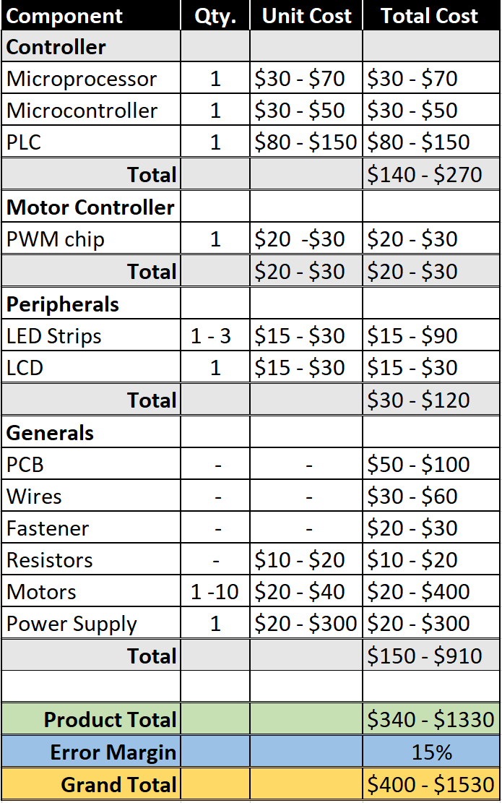

*Figure 3: Cost Breakdown*

## Timeline

The purpose of the project timeline is to lay out the deadlines for the different sections of the design process to help the team stay on track in finishing the vending machine design this semester.

*Figure 5: Tentative Schedule*

Above is the tentative outline for the project’s benchmarks and deadlines. Phase 1 is focused on formulating and discovering possible solutions, ending with our proposal for the project. Phase 2 is the designing process in which there will be research and development of the final product. Phase 3 is the construction of the final build. This is paired with Phase 4, the final testing and adjustment phase, ending with the final presentation.

# Conclusion

Vending machines are a convenient and efficient way to distribute products to meet the demand of those who require them. The purpose of this capstone project is to not only design and create an easier system for students to procure their needed class kit boards and devices, but also to lighten the load off of the employees in the ECE department. The Class Kit Vending Machine will be an efficacious solution to the problem formulated in this project proposal.

# References

1. Elisabeth, “Vending Machines have advantages,” Camelback Vending, 16-Jul-2018. [Online]. Available: https://camelbackvending.com/vending-machines-advantages/#:~:text=Vending%20machines%20are%20convenient%20and%20they%20allow%20your%20employees%20and,are%20in%20the%20right%20location. [Accessed: 23-Sep-2022].
2. Elipse, “Which power supply fits the design of a vending machine?,” *Elipse*, 31-Mar-2022. [Online]. Available: https://www.elipse.eu/en/which-power-supply-fits-the-design-of-a-vending-machine/. [Accessed: 23-Sep-2022].
3. Admin, “Why do vending machines get stuck,” *Vending Business Machine Pro Service*, 15-May-2021. [Online]. Available: https://vendingproservice.com/why-do-vending-machines-get-stuck/. [Accessed: 23-Sep-2022].
4. C. Blomquist and C. Blomquist, “The benefits of offline vs. online vending machines (infographic),” *Parlevel Systems*, 11-Aug-2022. [Online]. Available: https://www.parlevelsystems.com/2018/10/23/online-offline-infographic/#:~:text=Through%20telemetry%2C%20vending%20machines%20can,communicated%20to%20a%20vending%20operator. [Accessed: 23-Sep-2022].
5. Privacy and Security Fanatic By Ms. Smith and M. Smith, “University attacked by its own vending machines, Smart Light Bulbs & 5,000 IOT devices,” *CSO Online*, 12-Feb-2017. [Online]. Available: https://www.csoonline.com/article/3168763/university-attacked-by-its-own-vending-machines-smart-light-bulbs-and-5-000-iot-devices.html. [Accessed: 23-Sep-2022].
6. “NFPA 70®,” *NFPA 70®: National Electrical Code®*. [Online]. Available: https://www.nfpa.org/codes-and-standards/all-codes-and-standards/list-of-codes-and-standards/detail?code=70. [Accessed: 23-Sep-2022].
7. “WIFI vs. Bluetooth: Wireless Electronics Basics: Eagle: Blog,” *Eagle Blog*, 02-Feb-2021. [Online]. Available: https://www.autodesk.com/products/eagle/blog/wifi-vs-bluetooth-wireless-electronics-basics/#eagle-navigation. [Accessed: 23-Sep-2022].
8. “The National Electrical Code (NEC),” *Electrical Safety Foundation International*, 13-Jul-2021. [Online]. Available: https://esfi.org/workplace-safety/industry-codes-regulations/the-national-electrical-code-nec/. [Accessed: 23-Sep-2022].
9. “IEEE SA - 2023 National Electrical Safety Code(R) (NESC(R)),” *IEEE Standards Association*. [Online]. Available: https://standards.ieee.org/ieee/C2/10814/. [Accessed: 23-Sep-2022].
10. “IEEE policies.” [Online]. Available: https://www.ieee.org/content/dam/ieee-org/ieee/web/org/about/corporate/ieee-policies.pdf. [Accessed: 23-Sep-2022].
11. “How a smart vending machine works,” *TCN Vending*, 27-Feb-2020. [Online]. Available: https://www.tcnvending.com.au/blog/how-a-smart-vending-machine-works/. [Accessed: 23-Sep-2022].
12. “Elevator vending machine: TCN Vending,” *Elevator Vending Machine | TCN Vending*, 11-Mar-2022. [Online]. Available: https://www.tcnvending.com.au/elevator-vending-machine/. [Accessed: 23-Sep-2022].